2019 NATIONAL DINNER THEATRE SPRING CONFERENCE
SPEAKER BIOGRAPHIES

CECI DADISMAN, THE FORM GROUP
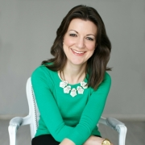
Ceci is a multi-faceted marketing professional with over 10 years of experience successfully marketing the arts and nonprofits utilizing innovative and cutting-edge initiatives. Currently the Digital Marketing Manager at FORM, she is nationally recognized as a leader in digital and social media marketing and specializes in the integration of digital marketing and technology into traditional marketing methods. Ceci is passionate about empowering people through marketing and is a contributor to Arts Hacker where she regularly shares timely information and step-by-step tutorials. She also teaches the arts marketing course at West Virginia University’s College of Creative Arts. A chronic early-adopter, Ceci has a passion for discovering ways that technology can be used to create more engaging arts experiences. The Curated Arts Experience focuses on collecting real-world case studies about how organizations around the world are using technology to engage the participant or enrich the experience at an arts event. She is on the Arts Midwest Conference Professional Development Committee, is the Immediate Past President and Chapter Founder of Femfessionals West Palm Beach, the Immediate Past Chapter Leader and Chapter Founder of the West Palm Beach Chapter of Girl Develop It, the Immediate Past President of the South Florida Chapter of the American Marketing Association, and served for many years on the National Arts Marketing Project Advisory Committee and as the OPERA America Marketing Network Chair. She also serves on the West Virginia University College of Creative Arts Visiting Committee.

DON OVERCASH, SANDLER TRAINING
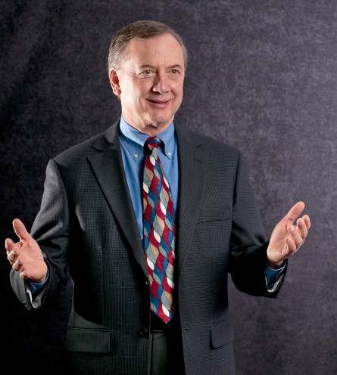
Don began his career as a pharmacist and developed his entrepreneurial skills through ownership of a community pharmacy. He moved from pharmacy retail to sales and marketing positions and then to a healthcare advertising agency, which led him to Sandler Training as a client. By 2009, Don had served as President/Turn-Around Specialist of three companies. He built business development teams that consistently delivered stellar results. With his strong track record and nearly 35 years of business development experience, he joined Sandler Training/Topline Growth in 2009 as an authorized trainer and principal. Today he remains passionate about bringing value to organizations and helping individuals to develop and grow through Sandler Training. He received his B.S. Pharmacy from the University of Illinois College of Pharmacy and later earned his MBA from the Keller Graduate School of Management. And here’s a fun fact: in 1979, Don conceived and co-founded a unique community event, The International Eelpout Festival—Google it!—that has continued for 40 years and draws thousands of visitors each winter to Walker, MN, bolstering the region’s tourism industry!

MORGAN MARAVICH, NATIONAL TOUR ASSOCIATION
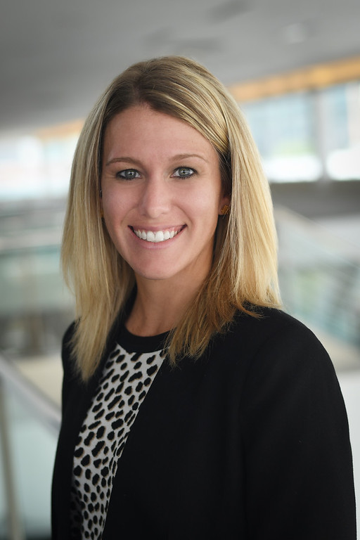
Morgan Maravich serves as director, partnerships and engagement, for the National Tour Association. She received her B.S. in Health, Fitness and Recreation Resources with a concentration in Tourism and Event Management from George Mason University in 2009 before becoming the tourism sales manager at Destination DC. She recently received her Certified Tour Professional designation from the National Tour Association in December 2017, the Certified Travel Industry Specialist designation from the American Bus Association in January 2015, the Certified Student Travel Professional designation from the Student Youth Travel Association in August 2014 as well as her Certified Travel Associate designation in 2010. In addition to her work at Destination DC, Maravich has been actively involved with NTA, ABA and SYTA. She sat on various committees, which included NTA's Young Professionals Advisory Group and spent time as an associate director member of the SYTA Board of Directors. Most recently, she was elected to serve as the president for 2019 for the Washington, D.C., chapter of SKAL International as well as a member of the Board of Directors for Visit Fairfax. For 2014, Groups Today Magazine named Maravich one of the Top Ten Next Gens in Group Travel. Additionally, the Washington, D.C. Guild of Professional Tour Guides awarded her as the recipient of their 2015 Tourism Industry Contribution Award. Maravich has also served as co-president for the College of Education and Human Development chapter on the George Mason University Alumni Board. She currently resides in Virginia.

NICOLE YOST, FOUNDER AND PRESIDENT OF FYN PUBLIC RELATIONS

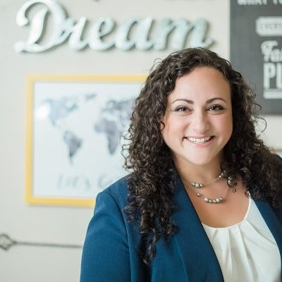
Nicole started Fyn (pronounced fine) Public Relations in 2011 after working for several PR firms in Denver, representing international clients in real estate, travel/tourism, B2B technology, B2C technology and key verticals including healthcare, education and government. Fyn Public Relations is a reputation management and public relations firm serving clients across Colorado and beyond. Fyn PR is a boutique firm that brings international experience to northern Colorado. They keep their client list small and focused to ensure that their clients get their A-team every time. They are communication counselors. They are reputation managers. They are expertly trained and experienced in public relations, strategic communications, digital and social public relations and storytelling. For them, managing your reputation and your story isn't a hobby. It isn't a job. It is a partnership where they treat your brand like their own. They believe that worthwhile public relations must create and promote change in your organization and meet your business needs, not just create one-off metrics. They are connectors. They connect your business success to your PR program. They connect your brand to influencers, partners, clients, consumers, customers, media and everyone in between for maximum visibility and, in turn, results.

