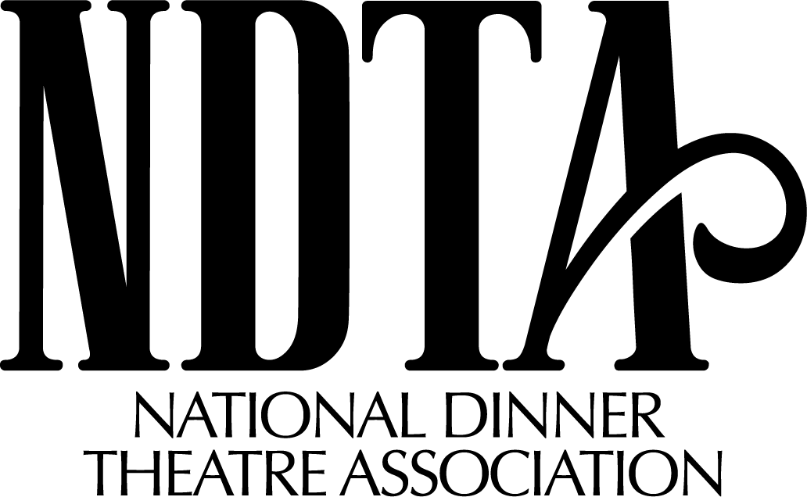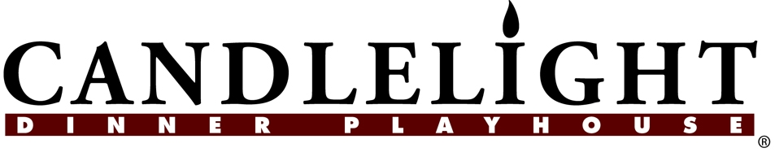
2019 Conference
Dear Participant,
Greetings from beautiful Colorado! We are so excited to be hosting the 2019 conference here at the Candlelight! In this packet you will be receiving the itinerary and registration form. The deadline for registering for the conference is Monday April 15, 2019. Below is some valuable information regarding travel and getting here.

Travel Info: Candlelight Dinner Playhouse is conveniently located off I-25 between exit 252 and 254 in Johnstown, Colorado. The address is 4747 Market Place Drive, Johnstown, Colorado 80534.

Hotel Info: The NDTA has reserved a block of rooms at the Best Western of Loveland located at 5542 E US 34, Loveland, Colorado 80537. The Best Western of Loveland is located just 4 miles North of the Candlelight. The Special rate for rooms will be $112/room/night with King or Double sized beds. The hotel features a seasonal outdoor pool, firepit, fitness center, a restaurant with great hours, laundry, business center, Wi-Fi, satellite programming, mini-fridge and microwave in each room, and a complimentary hot/cold buffet breakfast each morning. You can reserve your reservation by calling 970-667-7810, make sure you mention National Dinner Theatre Conference to receive the group discount. They will also extend the group rate if you would like to stay a few more days to relax and explore.

Airport Information: You will be flying into Denver International Airport. There is limited shuttle and transportation service up to the conference location (we are about an hour away). It is recommended that you rent a car for your time here.

If you have any specific questions about location or hotel please feel free to reach out to Pat Payne here at Candlelight at 970-744-3752. We look forward to seeing you in Colorado in April!

Sincerely,

Dave Clark
Executive Producer
Candlelight Dinner Playhouse
NATIONAL DINNER THEATRE ASSOCIATION ANNUAL CONFERENCE

SATURDAY APRIL 27, 2019

2:30 Meet up in conference room to say hello to everyone!

3:00- 4:00 First Business Meeting at Hotel

5:00 Meet in hotel lobby to go to the theatre
Shuttle to Candlelight

5:15- 6:00 Drinks, and Appetizers at theatre

6:00- 10:30 Performance of Oliver followed by tours of facility

Back to hotel- Hospitality Suite- Monroe’s at hotel

SUNDAY APRIL 28, 2019
(meetings at the theatre)

9:00 Leave for Theatre

Arrive at Candlelight Dinner Playhouse

9:30- 11:00 Workshop: Market Smarter, Not Harder: Using Your Own Data for Marketing Success: Do you use the same marketing plan for every show, and send your postcard to your entire list? Do you send the same sales material to all of your prospects? Not every patron will respond in the same way to your marketing message. The key to a successful marketing campaign is using data to deliver the right message to the right person at the right time. What is your marketing mix and is it reaching the right people? Speaker: Ceci Dadisman of Form

11:00- 11:15 Break

11:15- 12:45 Owners Only Meeting/Financial Sharing of End of Year 2018
This is for owners or shareholders to share information from discuss salaries, bonuses, organizational structures, employee issues, transitional ownership and more in a private setting.

11:15- 12:45 Email Marketing Makeover: Are you maximizing your email campaigns to drive open rates, engagement, and conversions? Learn best practices that can ensure clickthroughs and conversions to sales. Explore email automation functionality that will revolutionize the way you think about and deploy your email campaigns.
Speaker: Ceci Dadisman of The Form Group

12:45- 1:45 Lunch- Provided by Candlelight on site

1:45- 3:00 Roundtable with Royalty Houses: Join in a discussion with representatives from Theatrical Rights Worldwide, Concord Group (formerly Rogers and Hammerstein, Tams-Witmark and The Musical Company) among others to discuss. Find out what titles are coming and have a dialogue about the changes in the industry.

3:00 – 3:15 Break

3:15- 4:30 Hits and Pits and share packets

4:30 Break
Return to Hotel

5:30 or 6:00 Meet in Hotel lobby for dinner in Loveland, Colorado.

Hospitality Suite- Monroe’s at Hotel

MONDAY April 29, 2019

8:30 Leave for Theatre

Arrive at Candlelight Dinner Playhouse

9:00- 10:30 Human Resources Workshop: It’s a tough hiring environment for everyone right now. How do you hire the right people and keep them happy so they stay? How to Make Your Employees Cheer about working for your company!
Speaker: TBA

10:30 -10:45 Break

10:45- 12:15 Workshop: Unintentionally Destroying The Customer Experience- Each of us can attest to the value of a great customer experience and customer referrals. Are there things that we do without realizing the negative feelings they might create with our customers? Speaker: Don Overcash of Sandler Training

12:15-12:30 Break

12:30- 2:00 Workshop/Lunch: A seminar on the hot new items for your buffet or served menu and then they will host the lunch. Speaker: Shamrock Foods

2:00- 3:30 Workshop: The Landscape of Packaged Travel We’ll discuss the state of the packaged travel industry, both group and FIT, and the future of the market. We’ll also take a look at trends and travel markets that are on the rise. Speaker: Morgan Maravich, National Tour Association, CTP, CTIS, CSTP, Director, Partnerships & Engagement

3:30- 3:45 Break

3:45- 5:00 Nickel Ideas and Open Forums

5:00 Return to Hotel

6:00 Meet in Lobby of Hotel

6:30 Dinner – Nordy’s BBQ in Loveland

Return to Hotel

Hospitality Suite- Monroe’s at Hotel

TUESDAY April 30, 2019 at hotel

9:00 Leave for Theatre

9:30- 10:30 Workshop: PR: More than just media and reviews. PR is about managing your reputation through strategic communications and storytelling. Find out how to increase visibility for your theatre with different media, community and partnership opportunities. Speaker: Nicole Yost, FYN Public Relations/ Past President
PRSA Colorado

10:30- 10:45 Break

10:45- 12:30 Final Business Meeting

Conference is officially closed.

STAY AND BE A TOURIST DAY!

